
AI Project Report :

Daniel Cabral 90970308

25 May 2005

1. Critical Evaluation of Implementation 3
• .NET Framework v1.1.4322 3
• C# Language 3
• MS SQL Server 2000 (Developer’s Edition) 3
• VS .NET 2003 4
2. Critical Evaluation of Design 5
• Layered Architecture 5
• Strategy Pattern 6
3. Critical Evaluation of Intelligence of System [Ref. 3] 7
• Online Search 7
• Offline Search 7
4. Future Improvements 9
• Improve Efficiency of Online Search 9
• Improve Efficiency of Breadth First Search 9
5. References 10

Critical Evaluation of Implementation

I used the following software technologies to implement my AI project:

.NET Framework v1.1.4322
The .NET Framework is a development and execution environment that allows different programming languages & libraries to work together seamlessly to create Windows-based applications that are easier to build, manage, deploy, and integrate with other networked systems.
The .NET Framework consists of: [Ref. 1]
The Common Language Runtime (CLR)
A language-neutral development & execution environment that provides services to help "manage" application execution
The Framework Class Libraries (FCL)
A consistent, object-oriented library of prepackaged functionality

C# Language

C# is an object oriented programming language. .NET provides a high-level compiler that turns C# code into IL (Intermediate Language) which the CLR can execute. Object orientation allows for abstraction and other concepts such as encapsulation, composition and inheritance to be implemented. This helps developers tremendously when writing complex software such as AI development.

MS SQL Server 2000 (Developer’s Edition)

MS SQL Server was used as the persistence mechanism for all data needed for my AI program to run. It has proven to be reliable and stable and is optimized to run on windows platforms. I used stored procedures (which are basically pre-compiled queries) to improve the efficiency of updates to the database.

VS .NET 2003

Microsoft Visual Studio .NET was used to develop this project. The IDE (Integrated Development Environment) increased productivity immensely. Features such as code-completion, syntax highlighting made for faster development. The help functionality proved useful and made the assimilation of new libraries and classes easy. Also the debugger was an excellent tool to use when finding bugs or tracing through code.

Critical Evaluation of Design

Layered Architecture

I used a layered architecture to separate the different concerns of the program. This was used to make the program more maintainable, understandable and modular. Bottom layers should not be aware of layers above. This would allow for less dependencies between layers and thereby simplify the entire architecture. There are essentially 3 layers:

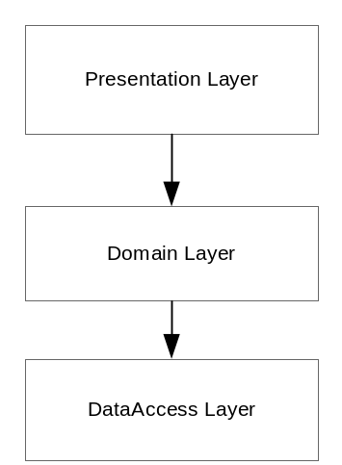

Figure 1 : Layered Architecture

    - Presentation Layer
In project “AI.Windows”. This consists of the forms and widgets of the forms. It provides the user-interface for the user to interact with the system. It also contains the controller functionality and delegates calls to the domain objects in the domain layer to do any complicated work.

    - Domain Layer
Relates to projects “AI.Environment”, “AI.Agent”. This is where the heart of the system is. It contains all the domain-specific concepts (eg.Percept, Action, etc.) and this is where the AI algorithms are implemented.

    - DataAccess Layer
Part of “AI.Agent”. This layer encapsulated the database implementation , in this case SQL Server. If one decides to use a different persistence mechanism (eg. XML files). They only need to change this layer.

Strategy Pattern

I used the strategy pattern when implementing the AI algorithms. [Ref. 2]. Strategy pattern can be used when you have a family of algorithms (in this case AI algorithms). The strategy pattern encapsulates each one and makes them interchangeable. Strategy lets the algorithm vary independently from the clients that use it.

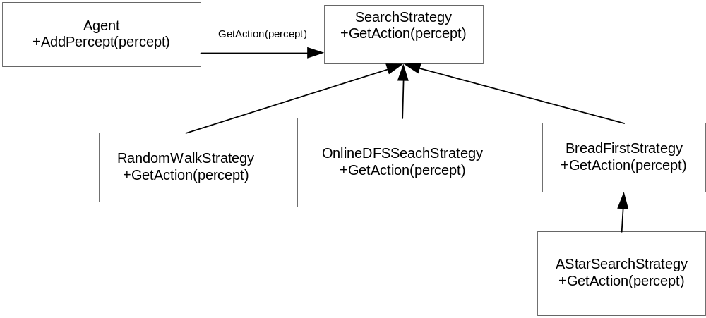

Figure 2 : Strategy Pattern

Critical Evaluation of Intelligence of System [Ref. 3]

Online Search

Initially the agent knows nothing about its environment, this is an example of an exploration problem where the states and actions to be taken are unknown. Since the agent is in a state of ignorance it must use its actions to experiment and determine what to do next. Therefore it must interleave computation and action. We will evaluate 2 algorithms namely Random Walk and Online Depth First Search:

  - Random Walk

A random walk simple selects at random one of the available actions from the current state; preference can be given to actions that have not been tried yet. Random walk will eventually complete it’s objective of cleaning all the windows since the state space is finite. It will also provide the most information of the environment. On the other hand, this is very slow.

  - Online Depth First Search

Since an online algorithm can only expand a node that it physically occupies, it is better to expand the node locally. Depth-first search has exactly this property, because the next node expanded is a child of the previous node expanded. When this algorithm is executed the results from executing an action in a specific state is recorded. Whenever an action from the current state has not been explores, the agent tries that action. The difficulty comes when the agent has tried all the actions in a state. The agent must then backtrack physically by going back to the state from which the agent entered the current state most recently. This is achieved by keeping a table that lists, for each state, the predecessor states to which the agent has not yet backtracked. In this case the state is the location of the agent Eg. Row,column.

Offline Search

Once the agent has performed and online search with the recorded result being saved, it can use this information to compute a solution before starting to clean the windows. We will evaluate 2 algorithms namely Breadth First Search and A*:

  - Breadth First Search

Is a simple strategy in which the root node is expanded first, then all the successors of the root node are expanded next, then their successors and so on. In general, all nodes are expanded at a given depth on the search tree before any nodes at the next level are expanded. I found that as the depth increases the memory requirements also increased and I eventually ran out of memory. For example the maximum branching factor would be 4 (agent can move to left, right,up,down location) and take a depth of 10 for a medium building the number of nodes would be : 4 + 4p2(4 to the power of 2) + 4p3 .. + .4p10 . Therefore the memory requirements are the biggest problem for this algorithm. I found out that this works well for the smaller state spaces (ie. Small building), but when using it with medium to large buildings it takes too much memory.

  - A* Algorithm

I used this algorithm to find the most optimal solution to clean all the windows. I used the “Manhattan distance” heuristic to find the shorted distances when locating windows o be cleaned. Eg. Say now my agent is located in row 3, column 3. It now has a choice to either move to 3,4 or 4,3. The state space consists of 2 windows located in 5,5 and 7,1.

If the agent chose the first option the heuristic function would yield : (5-3) + (5-4) = 2 for the first window and (7-3) + (4-1) = 7 for the second window, total would be 9.

If the agent chose the second option the heuristic function would yield : ( 5-4) + (5-3) = 2 for the first window and (7-4) + (3-1) = 5 for the second window, total would be 7.

Therefore the node for the second choice would be expanded as part of the solution.

4. Future Improvements

Improve Efficiency of Online Search

The efficiency of online search can be improved with the use of a learning real-time A*(LRTA*) algorithm. Like Online-DFS , it builds a map of the environment using a table. It updates the cost estimate for the state is has left and then chooses the “apparently best” move according to its current cost estimates. One important detail is that actions that have not yet been tried in a state are always assumed to lead immediately to the goal with the least possible cost. This optimism under uncertainty encourages the agent to explore new , possible promising paths.

Improve Efficiency of Breadth First Search

Currently basic checking for repeated states is being used. For example the child node does not expand a node if it the same as its parent. It also does not expand a node if it is one of its ancestors. More sophisticated techniques can be used to be able to identify repeated states from other paths of the search tree. This will make the search faster by making the tree smaller but more resources would be needed for the overhead of identifying repeated states.

References

1 - http://msdn.microsoft.com/netframework/gettingstarted/default.aspx
2 - Design Patterns : Elements of reusable object-oriented software. Gamma, Helm, Johnson, Vlissides.
3 – AI A Modern Approach : Russel, Norvig

UNIVERSITY OF JOHANNESBURG

STANDARD-BANK ACADEMY FOR
INFORMATION TECHNOLOGY

DECLARATION ON SUBMISSION OF ASSIGNMENTS FOR HONOURS

I _________________________________ with student number ________________
(Full Names and Surname)
ID Number _______________________________________, hereby declare that this assignment entitled:

_____________________________________________________________________

is my own work, and has not been published, even partially, anywhere else.

I also declare that not more than 10% of this assignment is directly quoted from any other published source, and that all sources used in this assignment are listed in the references of the assignment.

__________________________ _________________
SIGNATURE DATE

Telephone Numbers: Home: ___________________________________
Work: ___________________________________
Cell: ___________________________________

E-mail Address: ___________________________________

